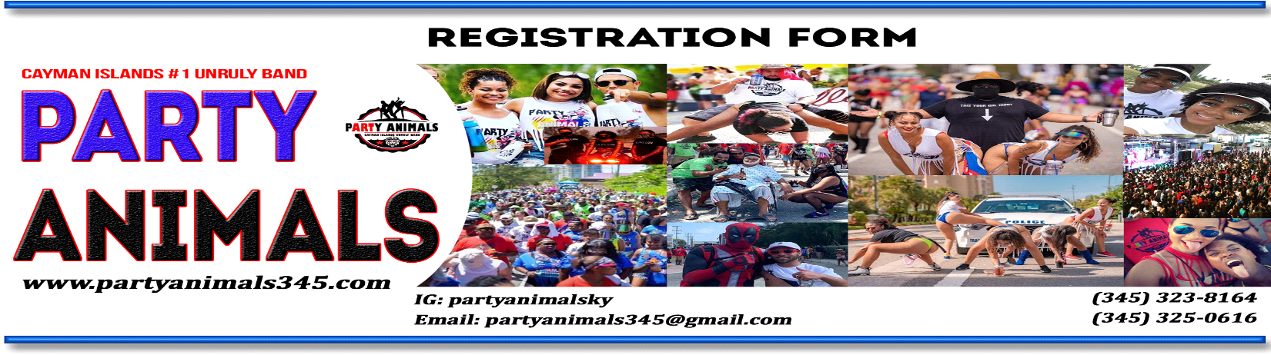
A non-refundable payment of $85 Per T-shirt is required to reserve your order. All payments are non-refundable as this payment secures your order until the deadline of balance due and shirts are printed to your request.

Please be advised that you have to be 18 and older to participate in CayMas Carnival.

To register, please complete the form and then send a watsapp to (345)323-8164 with a photo of your form. (Cash payments only - If you wish to pay by debit or credit card you can register online and make payment same time)
Please make sure you receive your receipt as it will be required to collect your Merchandise along with proof of Identification. Distribution day will be listed on our social media and web. Please put the correct information as we may have to contact you.

MAS CAMP HEADQUARTERS & REGISTRATION CENTRES (Additional Locations on Website)
Register – Watsapp (345)-323-8164 to register physically.
ONLINE REGISTRATIONS:

Full Name: _____________________________________ DOB: __________________ Phone: _____________________
Email:__________________________________________________________
Circle one: Male Female

TSHIRT CAYMAS TSHIRT COLOR (Option 1) T-SHIRT SECTION - $85
- Small ◻ X-Large ◻ WHITE ◻ BLUE ◻ RED
- Medium ◻ 2X-Large
- Large ◻ 3X-Large ◻ GREEN

I acknowledge that Party Animals Band will be taking part in Cayman CayMas Carnival throughout the streets of Grand Cayman. I verify that I am 18 years or older and my actions within the parade is solely my own and no responsibility of the Party Animals Mas Band or partners. I hereby agree to waive any and all liability of Party Animals Band, its directors, band leaders, partners, members, servants and sponsors arising out of any occurrences, incidents, accidents or events occurring during or in connection with the Mas Camp or CayMas Street Parade 2022, whatsoever. All payments are non-refundable.
_______________________________ THANK YOU!
Masquerader Signature

